AUTH-024
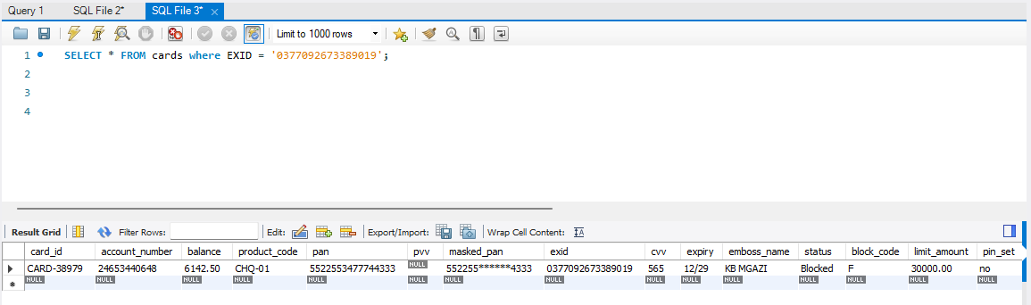
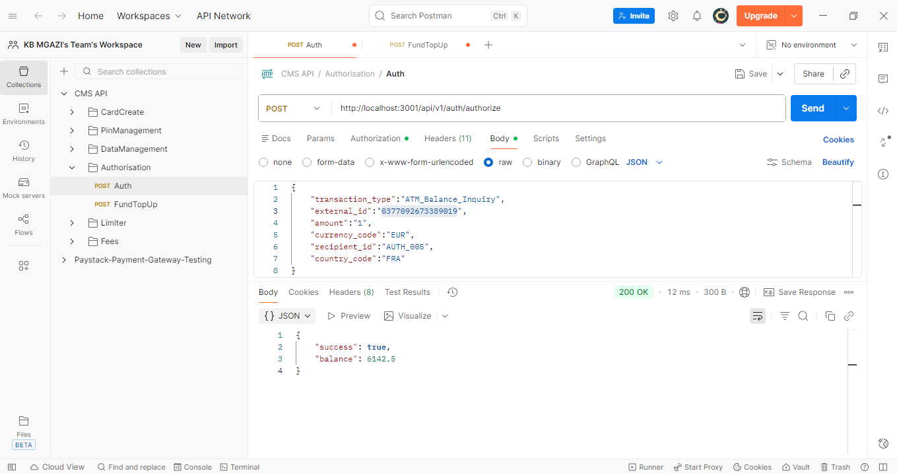
Request:
{
"transaction_type":"ATM_Balance_Inquiry",
"external_id":"0377092673389019",
"amount":"1",
"currency_code":"EUR",
"recipient_id":"AUTH_005",
"country_code":"FRA"
}
Response:
{
"success": true,
"balance": 6142.5
}

